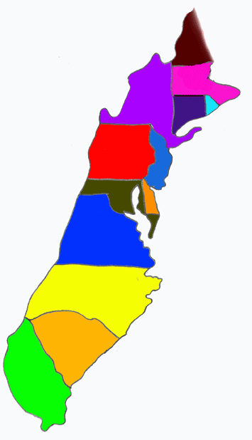
The Thirteen
Colonies

Social Studies
Mr. LaFortune

Due: December 11, 2012

Name: ____________________
Block: _____
New England Colonies:
Massachusetts
(Plymouth Colony & Massachusetts Bay Colony)

Date Founded: __________ First Charter Date: _________
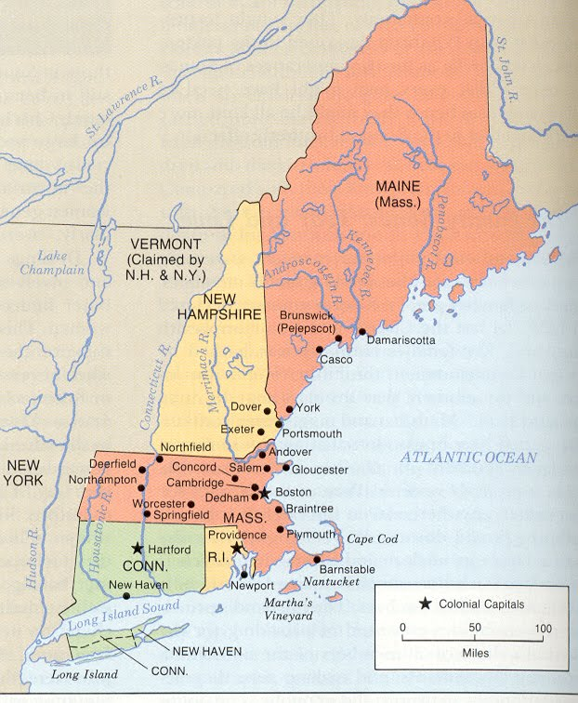
Capital/Important City: __________

Founders/Important Colonists:
___________________ __________________
___________________ __________________
___________________ __________________

Reason for / History of Settlement:
_________________________________________________________________________________________________________________________________________________________________________________

Major Industry / Economy / Occupations:
___________________ __________________
___________________ __________________

Religion(s): ________________________________________________

Government: _______________________________________________

Status of Slavery in Colony: _______________________________
New England Colonies:
Connecticut

Date Founded: __________ First Charter Date: __________
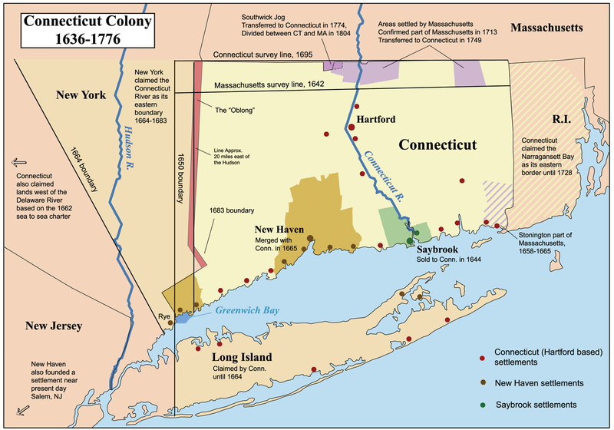
Capital/Important City: __________

Founders/Important Colonists:
___________________ __________________
___________________ __________________
___________________ __________________

Reason for / History of Settlement:
_________________________________________________________________________________________________________________________________________________________________________________

Major Industry / Economy / Occupations:
___________________ __________________
___________________ __________________

Religion(s): ________________________________________________

Government: _______________________________________________

Status of Slavery in Colony: _______________________________

New England Colonies:
Rhode Island

Date Founded: __________ First Charter Date: __________
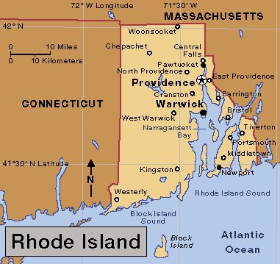
Capital/Important City: __________

Founders/Important Colonists:
___________________ __________________
___________________ __________________
___________________ __________________

Reason for / History of Settlement:
_________________________________________________________________________________________________________________________________________________________________________________

Major Industry / Economy / Occupations:
___________________ __________________
___________________ __________________

Religion(s): ________________________________________________

Government: _______________________________________________

Status of Slavery in Colony: _______________________________
New England Colonies:
New Hampshire

Date Founded: __________ First Charter Date: __________
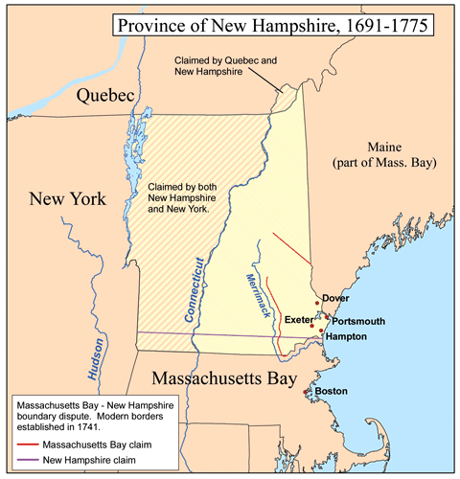
Capital/Important City: __________

Founders/Important Colonists:
___________________ __________________
___________________ __________________
___________________ __________________

Reason for / History of Settlement:
_________________________________________________________________________________________________________________________________________________________________________________

Major Industry / Economy / Occupations:
___________________ __________________
___________________ __________________

Religion(s): ________________________________________________

Government: _______________________________________________

Status of Slavery in Colony: _______________________________
Middle Colonies:
Virginia

Date Founded: __________ First Charter Date: __________
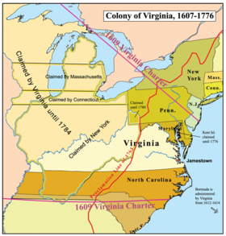
Capital/Important City: __________

Founders/Important Colonists:
___________________ __________________
___________________ __________________
___________________ __________________

Reason for / History of Settlement:
_________________________________________________________________________________________________________________________________________________________________________________

Major Industry / Economy / Occupations:
___________________ __________________
___________________ __________________

Religion(s): ________________________________________________

Government: _______________________________________________

Status of Slavery in Colony: _______________________________
Middle Colonies:
New York

Date Founded: __________ First Charter Date: __________
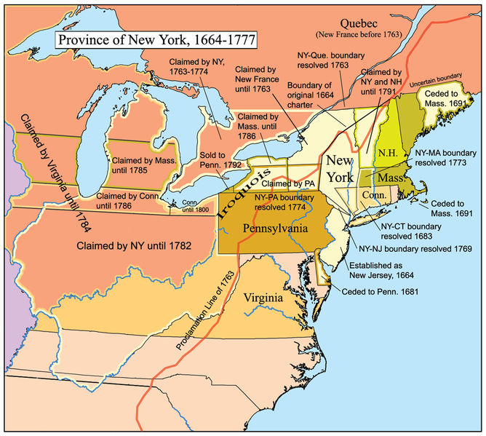
Capital/Important City: __________

Founders/Important Colonists:
___________________ __________________
___________________ __________________
___________________ __________________

Reason for / History of Settlement:
_________________________________________________________________________________________________________________________________________________________________________________

Major Industry / Economy / Occupations:
___________________ __________________
___________________ __________________

Religion(s): ________________________________________________

Government: _______________________________________________

Status of Slavery in Colony: _______________________________
Middle Colonies:
New Jersey

Date Founded: __________ First Charter Date: __________
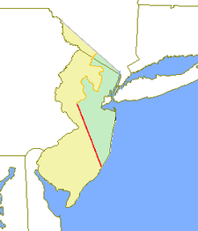
Capital/Important City: __________

Founders/Important Colonists:
___________________ __________________
___________________ __________________
___________________ __________________

Reason for / History of Settlement:
_________________________________________________________________________________________________________________________________________________________________________________

Major Industry / Economy / Occupations:
___________________ __________________
___________________ __________________

Religion(s): ________________________________________________

Government: _______________________________________________

Status of Slavery in Colony: _______________________________
Middle Colonies:
Pennsylvania

Date Founded: __________ First Charter Date: __________
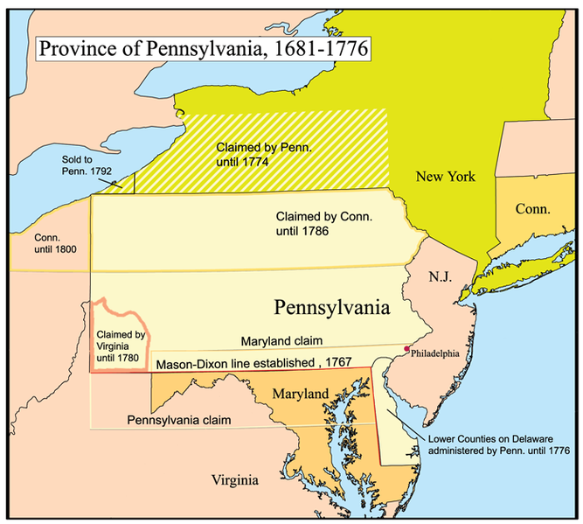
Capital/Important City: __________

Founders/Important Colonists:
___________________ __________________
___________________ __________________
___________________ __________________

Reason for / History of Settlement:
_________________________________________________________________________________________________________________________________________________________________________________

Major Industry / Economy / Occupations:
___________________ __________________
___________________ __________________

Religion(s): ________________________________________________

Government: _______________________________________________

Status of Slavery in Colony: _______________________________
Middle Colonies:
Delaware

Date Founded: __________ First Charter Date: __________
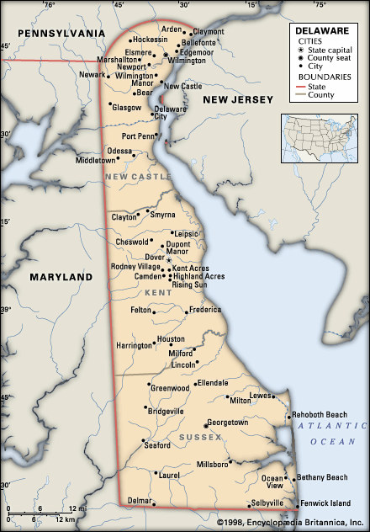

Capital/Important City: __________

Founders/Important Colonists:
___________________ __________________
___________________ __________________
___________________ __________________

Reason for / History of Settlement:
_________________________________________________________________________________________________________________________________________________________________________________

Major Industry / Economy / Occupations:
___________________ __________________
___________________ __________________

Religion(s): ________________________________________________

Government: _______________________________________________

Status of Slavery in Colony: _______________________________
Middle/Southern Colonies:
Maryland

Date Founded: __________ First Charter Date: __________
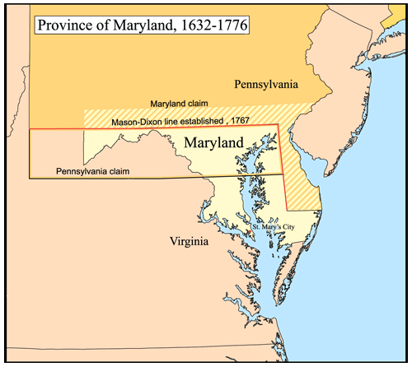
Capital/Important City: __________

Founders/Important Colonists:
___________________ __________________
___________________ __________________
___________________ __________________

Reason for / History of Settlement:
_________________________________________________________________________________________________________________________________________________________________________________

Major Industry / Economy / Occupations:
___________________ __________________
___________________ __________________

Religion(s): ________________________________________________

Government: _______________________________________________

Status of Slavery in Colony: _______________________________
Southern Colonies:
North Carolina

Date Founded: __________ First Charter Date: __________
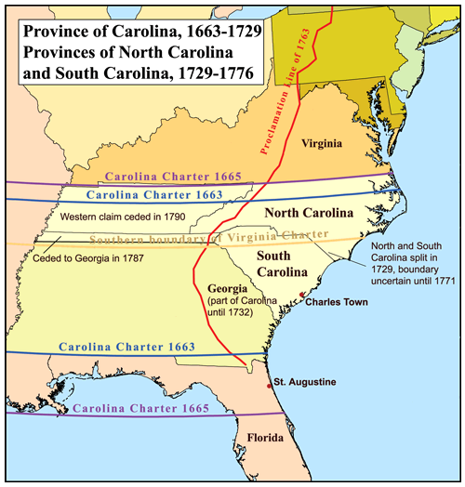
Capital/Important City: __________

Founders/Important Colonists:
___________________ __________________
___________________ __________________
___________________ __________________

Reason for / History of Settlement:
_________________________________________________________________________________________________________________________________________________________________________________

Major Industry / Economy / Occupations:
___________________ __________________
___________________ __________________

Religion(s): ________________________________________________

Government: _______________________________________________

Status of Slavery in Colony: _______________________________
Southern Colonies:
South Carolina

Date Founded: __________ First Charter Date: __________
Capital/Important City: __________

Founders/Important Colonists:
___________________ __________________
___________________ __________________
___________________ __________________

Reason for / History of Settlement:
_________________________________________________________________________________________________________________________________________________________________________________

Major Industry / Economy / Occupations:
___________________ __________________
___________________ __________________

Religion(s): ________________________________________________

Government: _______________________________________________

Status of Slavery in Colony: _______________________________
Southern Colonies:
Georgia

Date Founded: __________ First Charter Date: __________
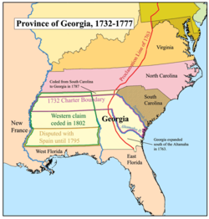
Capital/Important City: __________

Founders/Important Colonists:
___________________ __________________
___________________ __________________
___________________ __________________

Reason for / History of Settlement:
_________________________________________________________________________________________________________________________________________________________________________________

Major Industry / Economy / Occupations:
___________________ __________________
___________________ __________________

Religion(s): ________________________________________________

Government: _______________________________________________

Status of Slavery in Colony: _______________________________

The Thirteen Colonies

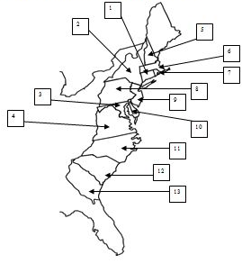
Label the Colonies on the lines.
Then color the map (using colored pencils) as follows:
New England Colonies: Blue
Middle Colonies: Green
Southern Colonies: Red
- ____________________________
- ____________________________
- ____________________________
- ____________________________
- ____________________________
- ____________________________
- ____________________________
- ____________________________
- ____________________________
- ____________________________
- ____________________________
- ____________________________
- ____________________________

